Introduction

Definitions:

From the Computer Security Handbook of the NIST from 1995:

* Computer Security:
  + The protection afforded to an automated information system in order to attain the applicable objectives of preserving the integrity, availability and confidentially of information system resources (includes hardware, software, firmware, information / data, and telecommunication)
* IT Security Management:
  + Process to achieve and maintain appropriate levels of confidentially, integrity, availability, authenticity and reliability

What do we want to protect? (Security goals)

* Confidentially: Keeping information / data secret
* Integrity: Keeping information / data correct and reliable
* Availability: Ensuring information / data is available to the right people at the right time
* Authentication: Verifying an identity
* Authorization: Verifying access to resources
* Nonrepudiation: Validating the source of information
* Accountability: Verifying the responsibility of subjects for their actions

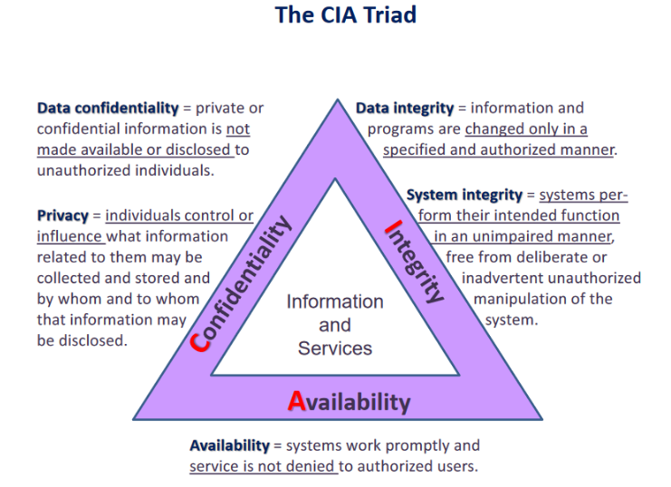CIA Triangle